**Class Diagram**

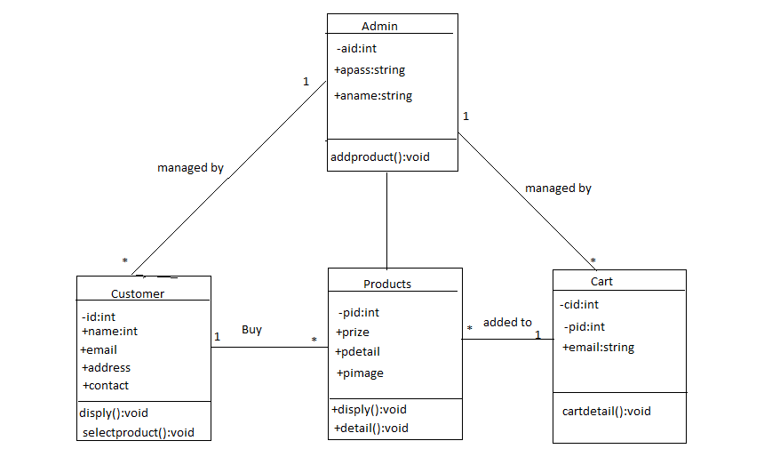

**Usecase Diagram**

Admin

Customer

**Sequence Diagram (User)**

Web Application

Customer

Database

Visits

Create account

Message received Information Stored

Login

Validates information

View product Check Availability

Item Available

Add to cart

Check out

Bill payment

Database updated

Logout conformation message

**Sequence Diagram (Admin)**

Web Application

admin

Database

login Validates information

Access Granted

Add or update products database updated

View user information

View cart

Delete items database updated

Delivers items

Clears cart database updated

View feedback

Logout conformation message

**Activity Diagram(User)**

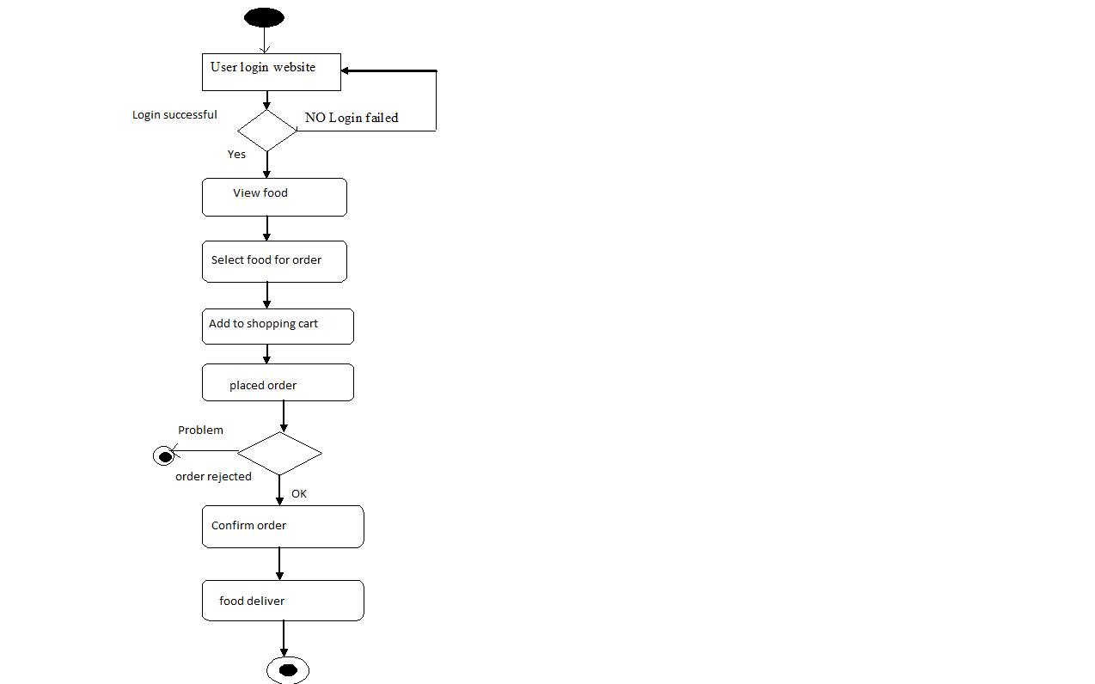

**Activity Diagram(Admin)**

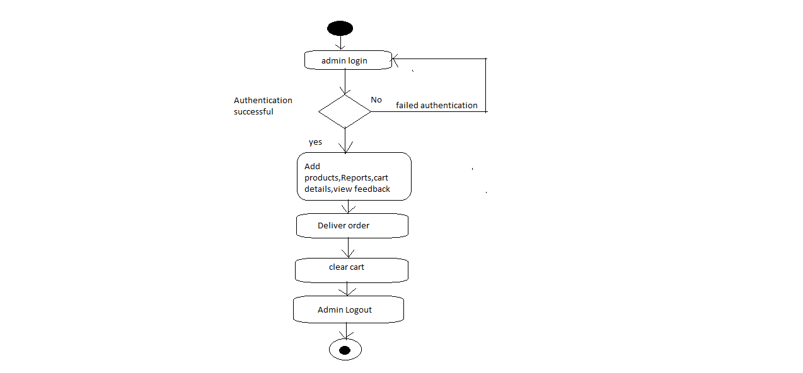

**Collabration Diagram**

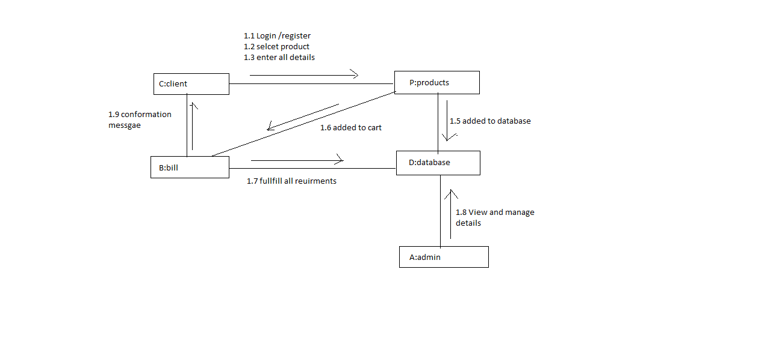

**Component Diagram**

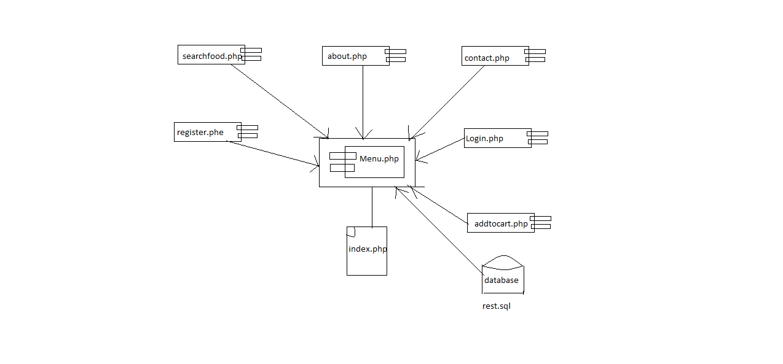

**Deployment Diagram**

